Алексеев Е. В. 223-321
Лабораторная работа №1
Вариант № 4

CREATE TABLE sport (
sport_id SERIAL PRIMARY KEY,
name VARCHAR(100) NOT NULL UNIQUE,
sport_type VARCHAR(20) NOT NULL
CHECK (sport_type IN ('командный', 'индивидуальный', 'смешанный'))
);

CREATE TABLE discipline (
discipline_id SERIAL PRIMARY KEY,
sport_id INTEGER NOT NULL REFERENCES sport(sport_id),
name VARCHAR(150) NOT NULL,
CHECK (length(trim(name)) > 0),
UNIQUE (sport_id, name)
);

CREATE TABLE venue (
venue_id SERIAL PRIMARY KEY,
name VARCHAR(200) NOT NULL,
address VARCHAR(300) NOT NULL,
capacity INTEGER CHECK (capacity IS NULL OR capacity > 0),
indoor BOOLEAN NOT NULL DEFAULT FALSE
);

CREATE TABLE organizer (
organizer_id SERIAL PRIMARY KEY,
organization_name VARCHAR(200) NOT NULL,
contact_person VARCHAR(200),
phone VARCHAR(30),
email VARCHAR(150)
);

CREATE TABLE competition (
competition_id SERIAL PRIMARY KEY,
organizer_id INTEGER NOT NULL REFERENCES organizer(organizer_id),
venue_id INTEGER NOT NULL REFERENCES venue(venue_id),
name VARCHAR(200) NOT NULL,
start_date DATE NOT NULL,
end_date DATE NOT NULL,
status VARCHAR(30) NOT NULL DEFAULT 'планируется'
CHECK (status IN ('планируется', 'регистрация', 'проводится', 'завершено', 'отменено')),
description TEXT,
CHECK (end_date >= start_date)
);

CREATE TABLE participant (
participant_id SERIAL PRIMARY KEY,
participant_type VARCHAR(20) NOT NULL
CHECK (participant_type IN ('спортсмен', 'команда')),
full_name VARCHAR(200) NOT NULL,
birth_date DATE,
phone VARCHAR(30),
email VARCHAR(150),
created_at TIMESTAMPTZ NOT NULL DEFAULT NOW()
);

CREATE TABLE team_member (
team_id INTEGER NOT NULL REFERENCES participant(participant_id),
athlete_id INTEGER NOT NULL REFERENCES participant(participant_id),
member_role VARCHAR(50) DEFAULT 'участник',
PRIMARY KEY (team_id, athlete_id),
CHECK (team_id <> athlete_id)
);

CREATE TABLE competition_discipline (
competition_id INTEGER NOT NULL REFERENCES competition(competition_id),
discipline_id INTEGER NOT NULL REFERENCES discipline(discipline_id),
participant_limit INTEGER CHECK (participant_limit IS NULL OR participant_limit > 0),
PRIMARY KEY (competition_id, discipline_id)
);

CREATE TABLE stage (
stage_id SERIAL PRIMARY KEY,
competition_id INTEGER NOT NULL,
discipline_id INTEGER NOT NULL,
stage_name VARCHAR(100) NOT NULL,
stage_date DATE NOT NULL,
stage_order INTEGER NOT NULL CHECK (stage_order > 0),
FOREIGN KEY (competition_id, discipline_id)
REFERENCES competition_discipline(competition_id, discipline_id),
UNIQUE (competition_id, discipline_id, stage_order)
);

CREATE TABLE judge (
judge_id SERIAL PRIMARY KEY,
full_name VARCHAR(200) NOT NULL,
qualification VARCHAR(100) NOT NULL,
phone VARCHAR(30)
);

CREATE TABLE judge_assignment (
judge_id INTEGER NOT NULL REFERENCES judge(judge_id),
stage_id INTEGER NOT NULL REFERENCES stage(stage_id),
judge_role VARCHAR(100) NOT NULL DEFAULT 'судья',
PRIMARY KEY (judge_id, stage_id)
);

CREATE TABLE registration (
registration_id SERIAL PRIMARY KEY,
participant_id INTEGER NOT NULL REFERENCES participant(participant_id),
competition_id INTEGER NOT NULL,
discipline_id INTEGER NOT NULL,
reg_date DATE NOT NULL DEFAULT CURRENT_DATE,
status VARCHAR(30) NOT NULL DEFAULT 'подана'
CHECK (status IN ('подана', 'подтверждена', 'отклонена', 'снята')),
FOREIGN KEY (competition_id, discipline_id)
REFERENCES competition_discipline(competition_id, discipline_id),
UNIQUE (participant_id, competition_id, discipline_id)
);

CREATE TABLE result (
result_id SERIAL PRIMARY KEY,
registration_id INTEGER NOT NULL REFERENCES registration(registration_id),
stage_id INTEGER NOT NULL REFERENCES stage(stage_id),
place INTEGER CHECK (place IS NULL OR place > 0),
score NUMERIC(10,2),
result_status VARCHAR(30) NOT NULL DEFAULT 'завершён'
CHECK (result_status IN ('завершён', 'не финишировал', 'дисквалифицирован', 'не явился')),
UNIQUE (registration_id, stage_id)
);

Модель 3NF

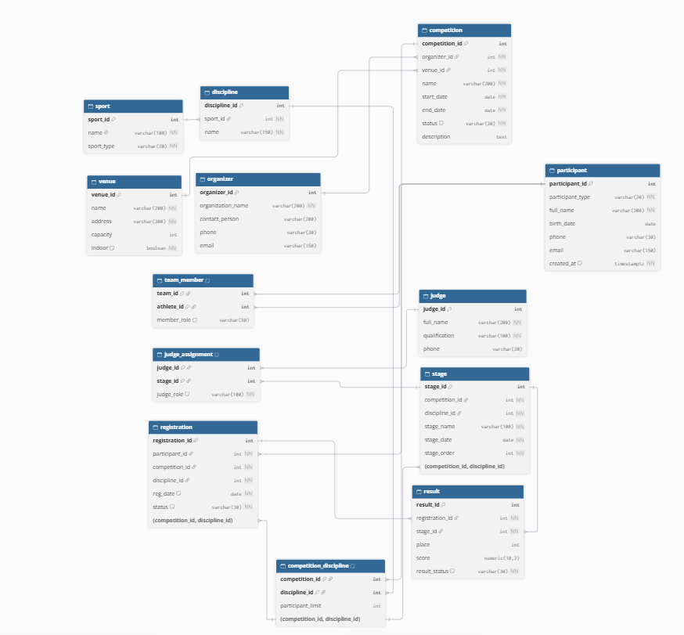

CREATE TABLE hub_competition (
competition_hk CHAR(32) PRIMARY KEY,
competition_bk VARCHAR(200) NOT NULL,
load_date TIMESTAMPTZ NOT NULL DEFAULT NOW(),
record_source VARCHAR(100) NOT NULL
);

CREATE TABLE hub_participant (
participant_hk CHAR(32) PRIMARY KEY,
participant_bk VARCHAR(200) NOT NULL,
load_date TIMESTAMPTZ NOT NULL DEFAULT NOW(),
record_source VARCHAR(100) NOT NULL
);

CREATE TABLE hub_discipline (
discipline_hk CHAR(32) PRIMARY KEY,
discipline_bk VARCHAR(200) NOT NULL,
load_date TIMESTAMPTZ NOT NULL DEFAULT NOW(),
record_source VARCHAR(100) NOT NULL
);

CREATE TABLE hub_stage (
stage_hk CHAR(32) PRIMARY KEY,
stage_bk VARCHAR(200) NOT NULL,
load_date TIMESTAMPTZ NOT NULL DEFAULT NOW(),
record_source VARCHAR(100) NOT NULL
);

CREATE TABLE hub_judge (
judge_hk CHAR(32) PRIMARY KEY,
judge_bk VARCHAR(200) NOT NULL,
load_date TIMESTAMPTZ NOT NULL DEFAULT NOW(),
record_source VARCHAR(100) NOT NULL
);

CREATE TABLE link_registration (
registration_hk CHAR(32) PRIMARY KEY,
participant_hk CHAR(32) NOT NULL REFERENCES hub_participant(participant_hk),
competition_hk CHAR(32) NOT NULL REFERENCES hub_competition(competition_hk),
discipline_hk CHAR(32) NOT NULL REFERENCES hub_discipline(discipline_hk),
load_date TIMESTAMPTZ NOT NULL DEFAULT NOW(),
record_source VARCHAR(100) NOT NULL
);

CREATE TABLE link_competition_stage (
comp_stage_hk CHAR(32) PRIMARY KEY,
competition_hk CHAR(32) NOT NULL REFERENCES hub_competition(competition_hk),
stage_hk CHAR(32) NOT NULL REFERENCES hub_stage(stage_hk),
load_date TIMESTAMPTZ NOT NULL DEFAULT NOW(),
record_source VARCHAR(100) NOT NULL
);

CREATE TABLE link_judge_assignment (
assignment_hk CHAR(32) PRIMARY KEY,
judge_hk CHAR(32) NOT NULL REFERENCES hub_judge(judge_hk),
stage_hk CHAR(32) NOT NULL REFERENCES hub_stage(stage_hk),
load_date TIMESTAMPTZ NOT NULL DEFAULT NOW(),
record_source VARCHAR(100) NOT NULL
);

CREATE TABLE sat_competition_details (
competition_hk CHAR(32) NOT NULL REFERENCES hub_competition(competition_hk),
load_date TIMESTAMPTZ NOT NULL,
load_end_date TIMESTAMPTZ,
hash_diff CHAR(32) NOT NULL,
venue VARCHAR(250),
organizer_name VARCHAR(200),
description TEXT,
record_source VARCHAR(100) NOT NULL,
PRIMARY KEY (competition_hk, load_date)
);

CREATE TABLE sat_competition_status (
competition_hk CHAR(32) NOT NULL REFERENCES hub_competition(competition_hk),
load_date TIMESTAMPTZ NOT NULL,
load_end_date TIMESTAMPTZ,
hash_diff CHAR(32) NOT NULL,
start_date DATE,
end_date DATE,
status VARCHAR(30),
record_source VARCHAR(100) NOT NULL,
PRIMARY KEY (competition_hk, load_date),
CHECK (end_date IS NULL OR start_date IS NULL OR end_date >= start_date)
);

CREATE TABLE sat_participant_details (
participant_hk CHAR(32) NOT NULL REFERENCES hub_participant(participant_hk),
load_date TIMESTAMPTZ NOT NULL,
load_end_date TIMESTAMPTZ,
hash_diff CHAR(32) NOT NULL,
participant_type VARCHAR(20),
full_name VARCHAR(200),
birth_date DATE,
contact_info VARCHAR(250),
record_source VARCHAR(100) NOT NULL,
PRIMARY KEY (participant_hk, load_date)
);

CREATE TABLE sat_discipline_details (
discipline_hk CHAR(32) NOT NULL REFERENCES hub_discipline(discipline_hk),
load_date TIMESTAMPTZ NOT NULL,
load_end_date TIMESTAMPTZ,
hash_diff CHAR(32) NOT NULL,
sport_name VARCHAR(100),
discipline_name VARCHAR(150),
is_team BOOLEAN NOT NULL DEFAULT FALSE,
record_source VARCHAR(100) NOT NULL,
PRIMARY KEY (discipline_hk, load_date)
);

CREATE TABLE sat_stage_details (
stage_hk CHAR(32) NOT NULL REFERENCES hub_stage(stage_hk),
load_date TIMESTAMPTZ NOT NULL,
load_end_date TIMESTAMPTZ,
hash_diff CHAR(32) NOT NULL,
stage_name VARCHAR(100),
stage_date DATE,
stage_order INTEGER,
location VARCHAR(250),
record_source VARCHAR(100) NOT NULL,
PRIMARY KEY (stage_hk, load_date)
);

CREATE TABLE sat_judge_details (
judge_hk CHAR(32) NOT NULL REFERENCES hub_judge(judge_hk),
load_date TIMESTAMPTZ NOT NULL,
load_end_date TIMESTAMPTZ,
hash_diff CHAR(32) NOT NULL,
full_name VARCHAR(200),
qualification VARCHAR(100),
contact_info VARCHAR(250),
record_source VARCHAR(100) NOT NULL,
PRIMARY KEY (judge_hk, load_date)
);

CREATE TABLE sat_registration_result (
registration_hk CHAR(32) NOT NULL REFERENCES link_registration(registration_hk),
load_date TIMESTAMPTZ NOT NULL,
load_end_date TIMESTAMPTZ,
hash_diff CHAR(32) NOT NULL,
registration_status VARCHAR(30),
place INTEGER,
score NUMERIC(10,2),
result_status VARCHAR(30),
record_source VARCHAR(100) NOT NULL,
PRIMARY KEY (registration_hk, load_date),
CHECK (place IS NULL OR place > 0)
);

Модель Data Vault
